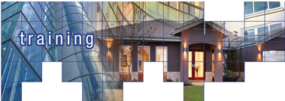
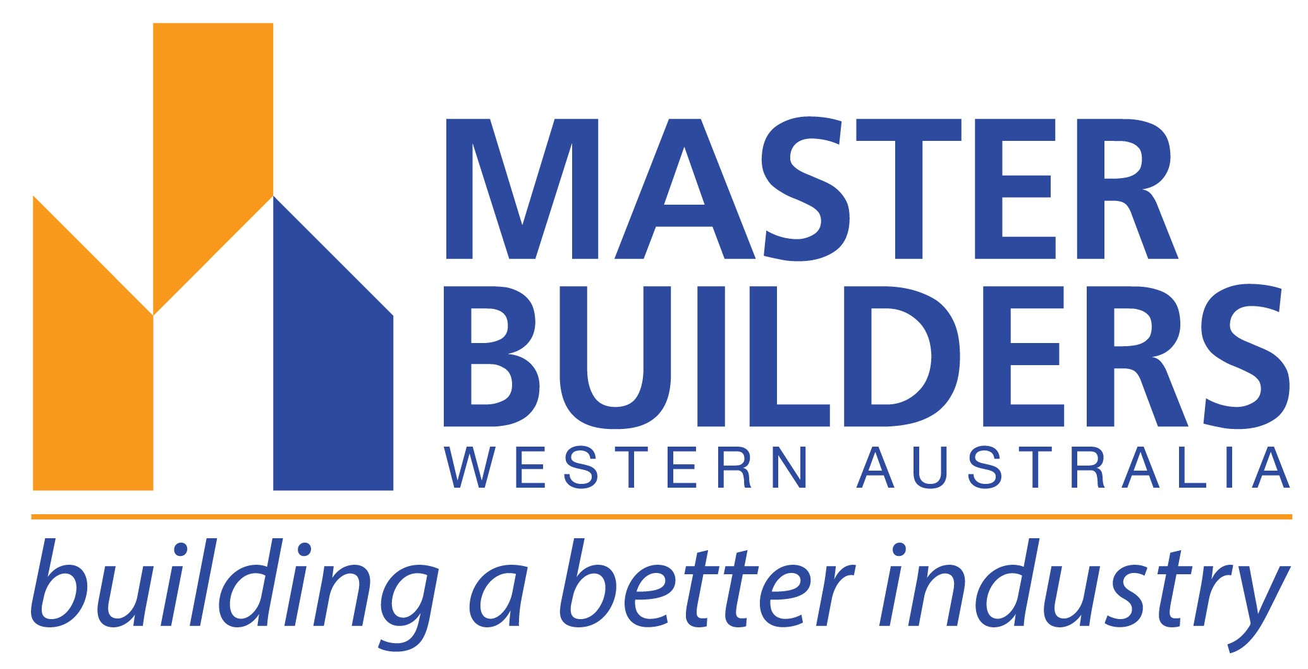

Wed 4 – Thurs 5 OCTOBER, 2017
SOUTH WEST
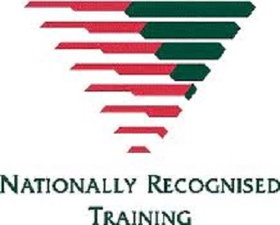

Licence to operate a boom-type elevating work platform (boom length greater than 11 metres or more)
(Registered Training Organisation Nara Training & Assessing 4518 will be the RTO issuing a Statement of Attainment)

This nationally accredited course is based upon the National Standard for Licensing Persons Performing High Risk Work.

Participants will undergo training in:

- Current legislation and requirements
- Hazard identifications & risk management
- Conducting routine checks, setting up, operating, shutting down and securing EWP
- Correctly accessing, installing and using fall protection equipment
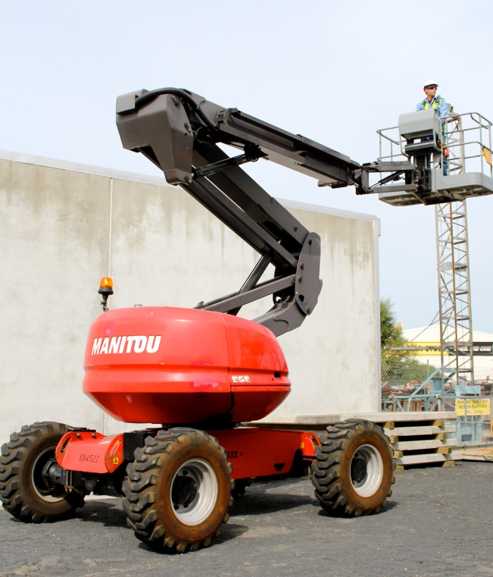

On day of course:-
- Please bring photo ID
- Wear appropriate protective clothing & footwear, no thongs/singlets.
- You must be a minimum of 18 years of age.
Upon successful completion of the course, you will be issued with a Statement of Attainment for TLILIC2005A Licence to operate a boom-type elevating work platform (boom length greater than 11 metres or more). Notice of Assessment (interim licence)

DATE: Wed 4 – Thurs 5 October, 2017
TIME: 8.00am - 4.00pm
TRAINER: Nara Training & Assessing
VENUE: Nara Training & Assessing, 26 Clifford Street, Bunbury
COST:
 | Course Fee | Total
MBA Member eligible for CTF subsidy | $360.00 - $288.00^ | $ 72.00*
Non-member eligible for CTF subsidy | $400.00 - $320.00^ | $ 80.00*
MBA Member | $360.00 | $360.00*
Non-member | $400.00 | $400.00*

PLEASE NOTE: An additional fee of $90.00 per person is also required for your WorkSafe Licence.

If you require further assistance, please contact the South West office on 9726 0939 or email southwest@mbawa.com

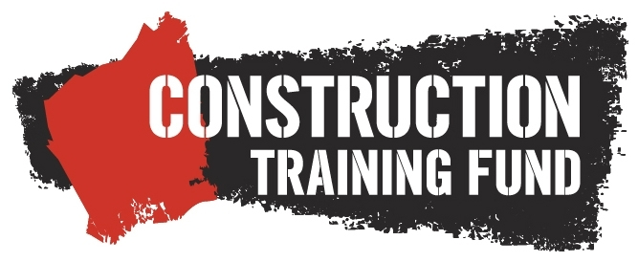
The Construction Training Fund provides funding support for training of eligible workers in the construction industry.
We acknowledge the support of the Construction Training Fund in reducing costs of training for eligible workers.

*Prices subject to change. ^Construction Training Fund (CTF) subsidy available for eligible course participants.
This course is GST free.

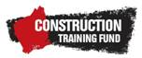 |  | 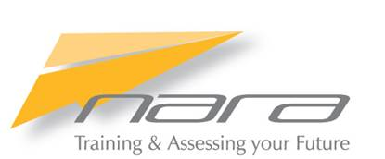
TLILIC2005A Elevated Work Platform
Wed 4 – Thurs 5 October, 2017 8.00am – 4.00pm

Please Note: This course is subsidised by the Construction Training Fund (CTF) for eligible participants. Master Builders requires participant’s details to be provided as indicated below otherwise the full fee may apply.

PARTICIPANT DETAILS:
Surname: |  | First name:
Date of birth: | Unique Student Identifier (USI):
Mobile: |  | Email:
Home address:
Suburb: |  |  | Postcode:
Job/Trade title:
Job description (brief detail):

EMPLOYER/COMPANY DETAILS:
Master Builders member name: member no: |  |  |  |  | Member no:
Employer/company name:
Builders Registration number: (if applicable)
Address: |  |  |  | Suburb:
Suburb: |  |  |  |  | Postcode:
Contact name: |  | Email:
Phone: | Fax: |  |  | Mobile:
Please tick the industry sector in which you work |  |  | Commercial □ Housing □ Engineering □

PAYMENT DETAILS
Payment must be received prior to the course date to secure your place & receive your confirmation.

EMAIL: southwest@mbawa.com
POST: Master Builders Association, PO Box 253, Bunbury WA 6231
Course Costs | Master Builder member | Non-member
Eligible for CTF subsidy | $ 72.00 per person | $ 80.00 per person
Not eligible for CTF subsidy | $360.00 per person | $400.00 per person

Please note that course costs are subject to change. This course is GST free
PLEASE NOTE: An additional fee of $90.00 per person is also required for your WorkSafe Licence

Method of Payment | Cash □ Cheque □ Credit Card □ EFT □ | Amount: $

Credit Card Details: |  | Bankcard □ MasterCard □ Visa □
Card number: _ _ _ _ / _ _ _ _ / _ _ _ _ / _ _ _ _ |  |  |  | Expiry Date: _ _ / _ _
Cardholders Name: |  |  | Signature:
EFT Direct Credit Details: BSB: 306 051 Account: 038 925 1 Reference: Please quote invoice number
Cancellation Notice | A refund will not be provided for no shows on the day of the course or cancellations less than 5 working days  prior to the course date. You may, however, substitute another person up to 48 hours prior to the course.

If you require further assistance, please contact the South West office on 9726 0939 or email southwest@mbawa.com

To view our Terms and Conditions please visit www.mbawa.com

